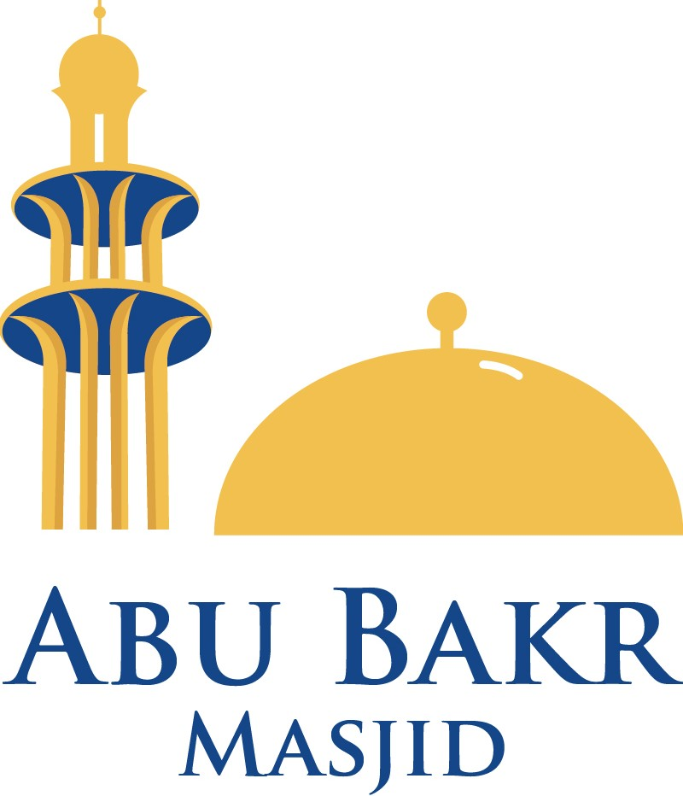 | Nikah (Marriage) Application Form
ABU BAKR ISLAMIC CENTRE
330 Oxford Road, Reading RG30 1AF www.abmreading.org info@abmreading.org
Date: |  | Ref no:
Details | Groom | Bride
Full name (As per ID)
Address

Date of birth
Place of birth
Marriage Status | Bachelor 🔲 Divorcee 🔲 Widower 🔲 | Single 🔲 Divorcee 🔲 Widow 🔲
Nationality
Phone no.
Email address
Passport no.
Wali’s Full name
(This will need to be the father or adult brother or Maternal / Paternal Uncle or Maternal / Paternal grandfather)
Details | Witness 1 | Witness 2
Full name
Address
Phone no.
Nationality
Mahr / Dowry: £ Mahr amount in words: Cash 🔲 Credit 🔲
Declaration by Groom and Bride
We, the undersigned, hereby declare that:
- The details given above are correct and true to the best of our knowledge.
- We bear witness that there is none worthy of worship except Allah and that Muhammad (PBUH) is His last messenger.
- It is permissible for us to marry each other under Islamic law and we are getting married with our mutual consent.
- We are aware of the law of the land with regards to marriage and as citizens must abide by those laws.
- We are aware that the Nikah certificate which shall be issued to us is only evidence of our marriage under Islamic guidance and it does not hold any legal status under the law of the United Kingdom.
Signature | Groom: | Bride:
Preferred Date for Nikah |  | Time of Nikah:
How many people will be attending the Ceremony

Office use only:
Received by _____________________________________________  Nikah Date: ______________________________________________  Date received: ____________________________________________  Name of Imam performing Nikah:  ________________________________________________________ | Receipt No. ____________________________________  Fee received: ___________________________________  Date: _________________________________________  Signature: ______________________________________

General Guidance

- Nikah (marriage) is performed with agreement (ijaab and qabool) by the bride and groom in the presence of two male or one male and two female Muslim witnesses.
- It is sunnah that the Nikah be announced and performed in the Masjid.
- The mahr (dowry) is the woman's right and should be stipulated prior to the Nikah. It should preferably be in the form of money (cash) and can be gifted at a later date.

Additional Notes and Fee
The Imam will only attend external venues as far as they are segregated, and no music is being played. Please confirm with the Imaam when the application is submitted. We prefer to perform Nikah ceremony at the Abu Bakr Masjid, however, if it is not possible and you need the Imam to perform Nikah at an external venue, it is your responsibility to provide two-way transportation for the Imam performing the Nikah.

Please provide the following before the ceremony date can be confirmed:
- Completed application form.
- Valid photo IDs and proof of address for both the bride and groom.
- Valid photo IDs for both the witnesses.
- The fee charged by the Trust for this ceremony is £100.00 cash paid in full before the ceremony.
Please note that this fee does not include any service charge by the Imam performing the Nikah. Families are kindly requested to make a separate contribution to the Imam in recognition of his time and services.
- Proof of divorce / Khula will be required where applicable.
- A minimum of 7 days notice should be given to the Nikah. Unfortunately, we are unable to cater for anything less than 7 days notice.
- A pre-Nikah meeting will take place with the Imaam performing the Nikah to ensure all documents are checked and the fee has been paid.
- The Imaam has the right to decline any request that is not within the Islamic guidelines.

The following will have to be adhered to during the ceremony:
- Bride and groom attendance.
- Wali (Bride’s Representative) attendance.
- Two male or one male and two female Muslim witnesses’ attendance pre-arranged before the Nikah by the Bride or Groom.

